

**Assignment: Image Processing 2**

**Topic:**

**Applying Slope, Aspect and Hill shading to DEM (Digital Elevation Model)**

Submitted by Submitted to

Maida Khalid (BS-SSR38F19) Sir Yaseen

**Department of Space science**

**University of the Punjab**

**Aspect and Slope**

The Aspect-Slope function creates a raster layer that simultaneously displays the aspect and slope of a surface.

Aspect identifies the downslope direction of the maximum rate of change in value from each pixel to its neighbors. Aspect can be thought of as the slope direction. The values of the output raster will be the compass direction of the aspect, represented by a hue (color).

Slope represents the rate of change of elevation for each digital elevation model (DEM) pixel, measured in degrees. Slope represents the steepness of the surface and is symbolized into three classes that are shown using color saturation (brightness).

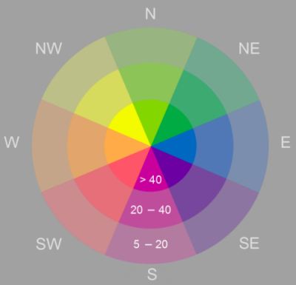

Aspect directions are represented by color, and the slope is represented by brightness. The slope values are in degrees, where the gray areas show slopes less than 5 degrees.The pixel values in the output aspect-slope raster reflect a combination of aspect and slope. Pixels with values below 20 are considered flat and are shown in gray. Aspect-slope values of 21 and above will be displayed with varying saturations as follows:

* 21 to 30—Low slope saturation
* 31 to 40—Moderate slope saturation
* 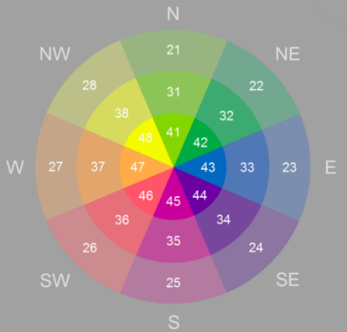41 and above—High slope saturation

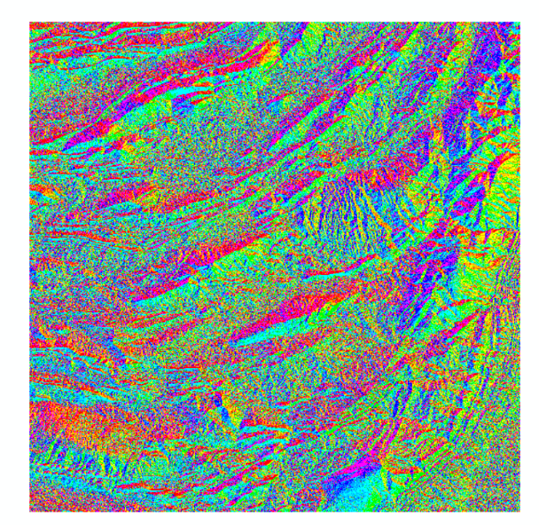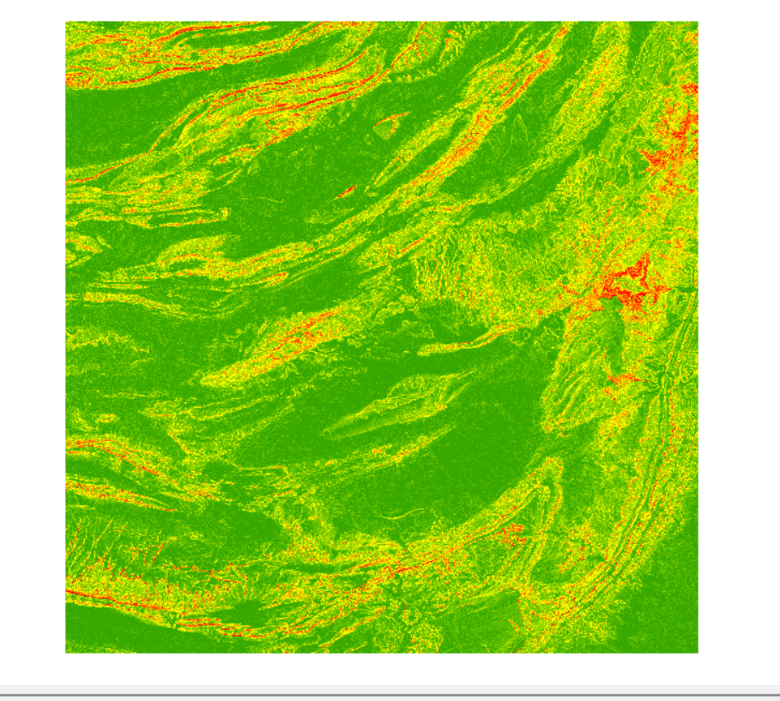

Slope

Aspect

**Hillshade (3D Analyst)**

* The Hillshade tool creates a shaded relief raster from a raster. The illumination source is considered to be at infinity.
* The hillshade raster has an integer value range of 0 to 255.
* Two types of shaded relief rasters can be output. If the **Model shadows** option is disabled (unchecked), the output raster only considers local illumination angle. If it is enabled (checked), the output raster considers the effects of both local illumination angle and shadow.
* The analysis of shadows is done by considering the effects of the local horizon at each cell. Raster cells in shadow are assigned a value of zero.
* To create a raster of the shadow areas only, use the [Con](https://pro.arcgis.com/en/pro-app/3.0/tool-reference/spatial-analyst/con-.htm), [Reclassify](https://pro.arcgis.com/en/pro-app/3.0/tool-reference/spatial-analyst/reclassify.htm), or [Extract by Attributes](https://pro.arcgis.com/en/pro-app/3.0/tool-reference/spatial-analyst/extract-by-attributes.htm) tool to separate the value zero from the other hillshade values. The **Model shadows** option must be enabled (checked) to create this result.
* If the input raster is in a spherical coordinate system, such as decimal degrees, the resulting hillshade may look peculiar. This is due to the difference in measure between the horizontal ground units and the elevation z units. Since the length of a degree of longitude changes with latitude, you will need to specify an appropriate z-factor for that latitude. If your x,y units are decimal degrees and your z units are meters, some appropriate z-factors for particular latitudes are:

Latitude Z-factor

0 0.00000898

10 0.00000912

20 0.00000956

30 0.00001036

40 0.00001171

50 0.00001395

60 0.00001792

70 0.00002619

80 0.00005156

* When the input raster needs to be resampled, the bilinear technique will be used. An example of when an input raster may be resampled is when the output coordinate system, extent, or cell size is different from that of the input.

